**PAPER O**

**MARK SCHEME**

**PURE MATHEMATICS**

**A level Practice Papers**

**(2 marks)**

|  |  |
| --- | --- |
| States that  **1** | **M1** |
| Makes an attempt to find  Writing or writing ln (sin *x*) constitutes an attempt. | **M1** |
| States a fully correct answer | **A1** |
| **TOTAL: 3 marks** |  |

|  |  |
| --- | --- |
| Begins the proof by assuming the opposite is true.  **2**  ‘Assumption: there exists a rational numbersuch thatis the greatest positive rational  number.’ | **B1** |
| Makes an attempt to consider a number that is clearly greater than:  ‘Consider the number, which must be greater than’ | **M1** |
| Simplifiesand concludes that this is a rational number.    By definition,is a rational number. | **M1** |
| Makes a valid conclusion.  This contradicts the assumption that there exists a greatest positive rational number,  so we can conclude that there is not a greatest positive rational number. | **B1** |
| **TOTAL: 4 marks** |  |

**3**

|  |  |
| --- | --- |
| Makes an attempt to find  Raising the power by 1 would constitute an attempt. | **M1** |
| States a fully correct answe r | **M1** |
| Makes an attempt to substitute the limits | **M1 ft** |
| Correctly states answer is | **A1 ft** |
| **TOTAL: 4 marks** |  |

|  |  |
| --- | --- |
| Makes an attempt to factor all the quadratics on the left-hand side of the identity.  **4** | **M1** |
| Correctly factors each expression on the left-hand side of the identity: | **A1** |
| Successfully cancels common factors: | **M1** |
| States that | **M1** |
| States or implies that *A* = 2, *B* = −9 and *C* = −18 | **A1** |
| **TOTAL: 5 marks** |  |

NOTES: Alternative method

Makes an attempt to substitute *x* = 0 (M1)

Finds *C* = −18 (A1)

Substitutes *x* = 1 to give *A* + *B* = −7 (M1)

Substitutes *x* = −1 to give *A* − *B* = 11 (M1)

Solves to get *A* = 2, *B* = −9 and *C* = −18 (**A1**)

**5**

|  |  |
| --- | --- |
| Begins the proof by assuming the opposite is true.  ‘Assumption: there exists a number *n* such that *n* is odd and *n*3 *+* 1 is also odd.’ | **B1** |
| Defines an odd number: ‘Let 2*k +* 1 be an odd number.’ | **B1** |
| Successfully calculates | **M1** |
| Factors the expression and concludes that this number must be even.    is even. | **M1** |
| Makes a valid conclusion.  This contradicts the assumption that there exists a number *n* such that *n* is odd and *n*3 *+* 1is also odd, so if *n* is odd, then *n*3 *+* 1 is even. | **B1** |
| **TOTAL: 5 marks** |  |

NOTES: Alternative method

Assume the opposite is true: there exists a number *n* such that *n* is odd and *n3 +* 1 is also odd. (**B1**)

If *n*3 *+* 1 is odd, then *n*3 is even. (**B1**)

So 2 is a factor of *n*3. (**M1**)

This implies 2 is a factor of *n*. (**M1**)

This contradicts the statement *n* is odd. (**B1**)

|  |  |
| --- | --- |
| Understands that for the series to be convergent  or states  **6a°** | **M1** |
| Correctly concludes that . Accept | **A1** |
|  | **(2 marks)** |
| Understands to use the sum to infinity formula. For example, states  **6b°** | **M1** |
| Makes an attempt to solve for *x*. For example,  is seen. | **M1** |
| States | **A1** |
|  | **(3 marks)** |
| **TOTAL: 5 marks** |  |

**7**

|  |  |
| --- | --- |
| States and | **M1** |
| Makes an attempt to solve the pair of simultaneous equations.  Attempt could include making a substitution or multiplying the first equation by 5 or by 7. | **M1** |
| Finds *a* = −4 | **A1** |
| Finds *b* = 6 | **A1** |
| States −2*abc* = −96 | **M1** |
| Finds *c* = −2 | **A1** |
| **TOTAL: 6 marks** |  |

|  |  |
| --- | --- |
| Understands the need to complete the square, and makes an attempt to do this.  **8**  For example, is seen. | **M1** |
| Correctly writes | **A1** |
| Demonstrates an understanding of the method for finding the inverse is to switch the *x* and *y*.  For example, is seen. | **B1** |
| Makes an attempt to rearrange to make *y* the subject.  Attempt must include taking the square root. | **M1** |
| Correctly states | **A1** |
| Correctly states domain is *x* > −9 and range is *y* > 4 | **B1** |
| **TOTAL: 6 marks** |  |

**9**

|  |  |
| --- | --- |
| Makes an attempt to set up a long division.  For example:  is seen.  The ‘0*x*’ being seen is not necessary to award the mark. | **M1** |
| Long division completed so that a ‘1’ is seen in the quotient  and a remainder of 25*x* + 32 is also seen. | **M1** |
| States | **M1** |
| Equates the various terms.  Equating the coefficients of *x*:  Equating constant terms: | **M1** |
| Multiplies one or both of the equations in an effort to equate one of the two variables. | **M1** |
| Finds | **A1** |
| Finds | **A1** |
| **TOTAL: 7 marks** |  |

**NOTES: Alternative method**

Writes  as 

States 

Substitutes  to obtain: 

Substitutes  to obtain: 

Equating the coefficients of *x*2: 

|  |  |
| --- | --- |
| States thatand concludes that  10 | **M1** |
| States thatand concludes that | **M1** |
| States that | **M1** |
| States thatand concludes thatoe. | **M1** |
| States thatand concludes thatoe. | **M1** |
| Recognises the need to use Pythagoras’ theorem. For example, | **M1** |
| Makes substitutions and begins to manipulate the equation: | **M1** |
| Uses a clear algebraic progression to arrive at the final answer: | **A1** |
| **TOTAL: 8 marks** |  |

|  |  |
| --- | --- |
| Statesand  11a | **M1** |
| Recognises that the identitycan be used to find the cartesian equation. | **M1** |
| Makes the substitution to find | **A1** |
|  | **(3 marks)** |
| States or implies that the curve is a circle with centre (−4, 3) and radius 7  11b | **M1 ft** |
| Substitutesto find *x* = −11 and *y* = 3 (−11, 3)  Substitutes to find *x* ≈ 2.06 and *y* = 6.5 (2.06, 6.5)  Could also substitute *t* = 0 to find *x* = −4 and *y* = 10 (−4, 10) | **M1 ft** |
| Draws fully correct curve. | **A1 ft** |
|  | **(3 marks)** |
| Makes an attempt to find the length of the curve by recognising that the length is part of the  11c  circumference. Must at least attempt to find the circumference to award method mark. | **M1 ft** |
| Uses the fact that the arc isof the circumference to write: arc length = | **A1 ft** |
|  | **(2 marks)** |
| **TOTAL: 8 marks** |  |

**NOTES:**

**11b** Award ft marks for correct sketch using incorrect values from part **a**.

**11c** Award ft marks for correct answer using incorrect values from part **a**.

**11c** Alternative method: use, withand

Award one mark for the attempt and one for the correct answer.

|  |  |
| --- | --- |
| Finds  and  12a | **M1** |
| Writes −2sin 2*t* = − 4sin *t* cos *t* | **M1** |
| Calculates | **A1** |
|  | **(3 marks)** |
| Evaluatesat  12b | **A1 ft** |
| Understands that the gradient of the tangent is, and then the gradient of the normal is −2 | **M1 ft** |
| Finds the values of *x* and *y* at  and | **M1 ft** |
| Attempts to substitute values into  For example, is seen. | **M1 ft** |
| Shows logical progression to simplify algebra, arriving at:  or | **A1** |
|  | **(5 marks)** |
| **TOTAL: 8 marks** |  |

**NOTES: 12b**

Award ft marks for a correct answer using an incorrect answer from part **a**.

|  |  |
| --- | --- |
| C:\Users\Haremi_0228\Desktop\Images\alevel_ut_p2_u9_test_aw2.png  Attempts to sketch  both and  13a | **M1** |
| States thatmeetsin just one place, therefore has just one root  has just one root | **A1** |
|  | **(2 marks)** |
| Makes an attempt to rearrange the equation. For example,  13b | **M1** |
| Shows logical progression to state  For example,is seen. | **A1** |
| 13c | **(2 marks)** |
| Attempts to use iterative procedure to find subsequent values. | **M1** |
| Correctly finds: *x*1 = 1.4463 *x*2 = 1.4709 *x*3 = 1.4594 *x*4 = 1.4647 | **A1** |
|  | **(2 marks)** |
| Correctly finds  13d | **A1** |
| Findsand | **M1** |
| Attempts to find: | **M1** |
| Finds | **A1** |
|  | **(4 marks)** |
| **TOTAL: 10 marks** |  |

**NOTES:**

**13a**

Uses their graphing calculator to sketch**** (**M1**)

**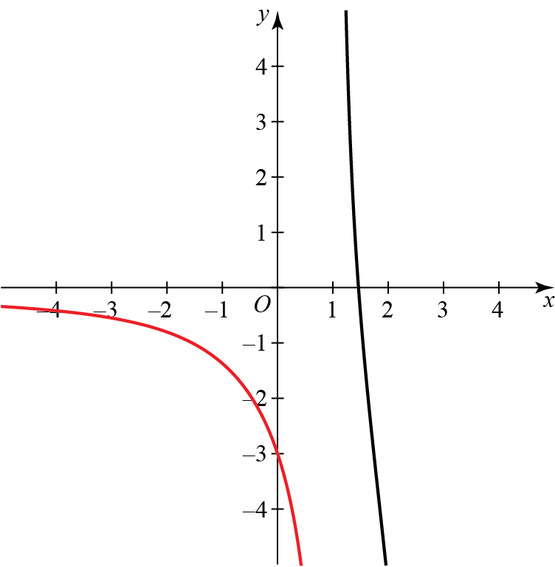**

States that as g(*x*) only intersects the *x*-axis in one place, there is only one solution. (**A1**)

**13c**

Award M1 if finds at least one correct answer.

14a

|  |  |
| --- | --- |
| Writes:  as | **M1** |
| Uses the binomial expansion to write: | **M1** |
| Simplifies to obtain: | **M1** |
| Writes the correct final answer: … | **A1 ft** |
|  | **(4 marks)** |
| Either states or states  14b | **B1** |
|  | **(1 mark)** |
| Makes an attempt to substitute  into  14c  For example | **M1** |
| Continues to simplify the expression:  **And** states the correct final answer: | **A1** |
|  | **(2 marks)** |
| Substitutes  into  Obtains:  14d | **M1 ft** |
| States that | **M1 ft** |
| Deduces that | **A1 ft** |
|  | **(3 marks)** |
| **TOTAL: 10 marks** |  |

**NOTES:**

**14a** Award 3 marks if a student has used an incorrect expansion but worked out all the other steps correctly.

**14d** Award all three marks if a student provided an incorrect answer in part **a**, but accurately works out

an approximation for root 2 consistent with this incorrect answer.

15a

|  |  |
| --- | --- |
| Correctly substitutes *x =* 1.5 intoand obtains 2.2323…  15a | **A1** |
|  | **(1 mark)** |
| States or implies formula for the trapezium rule:  15b | **M1** |
| Makes an attempt to substitute into the formula | **M1** |
| States correct final answer 1.610 (4 s.f.) | **A1** |
|  | **(3 marks)** |
| Recognises the need to make a substitution.  **Method 2**  is seen  15c  **Method 1**  is seen. | **M1** |
| Correctly statesand finds new  States and finds  and finds new limits and  limits  and | **M1** |
| Correctly transforms the integral  into  into | **M1** |
| Correctly finds the integral | **M1** |
| Makes an attempt to substitute the limits | **M1** |
| Correctly finds answer  **15c** Either method is acceptable. | **A1** |
|  | **(6 marks)** |
| Using more strips would improve the accuracy of the answer.  15d | **B1** |
|  | **(1 mark)** |
| **TOTAL: 11 marks** |  |

**(TOTAL: 100 MARKS)**