|  |  |
| --- | --- |
| **Pearson Edexcel Level 3** | |
| **GCE Mathematics**  **Advanced Level**  **Paper 1 or 2: Pure Mathematics** | |
| **Practice Paper D**  **Time: 2 hours** | **Paper Reference(s)** |
| **9MA0/01 or 9MA0/02** |
| **You must have:**  **Mathematical Formulae and Statistical Tables, calculator** | |

**Candidates may use any calculator permitted by Pearson regulations. Calculators must not have the facility for algebraic manipulation, differentiation and integration, or have retrievable mathematical formulae stored in them.**

**Instructions**

• Use black ink or ball-point pen.

• If pencil is used for diagrams/sketches/graphs it must be dark (HB or B).

• Answer **all** questions and ensure that your answers to parts of questions are clearly labelled.

• Answer the questions in the spaces provided – *there may be more space than you need*.

• You should show sufficient working to make your methods clear. Answers without working may not gain full credit.

• Inexact answers should be given to three significant figures unless otherwise stated.

**Information**

• A booklet ‘Mathematical Formulae and Statistical Tables’ is provided.

• There are 13 questions in this paper. The total mark is 100.

• The marks for each question are shown in brackets – *use this as a guide as to how much time to spend on each question.*

**Advice**

• Read each question carefully before you start to answer it.

• Try to answer every question.

• Check your answers if you have time at the end.

• If you change your mind about an answer, cross it out and put your new answer and any working underneath.

**Answer ALL questions.**

**1.** Given that

,

find the values of the constants *A*, *B* and *C*, where *A*, *B* and *C* are integers.

**(5 marks)**

___________________________________________________________________________________

**2.** (a) Use proof by contradiction to show that if *n*2 is an even integer then *n* is also an even integer.

**(4 marks)**

(b) Prove that √2 is irrational.

**(6 marks)**

___________________________________________________________________________________

**3.** Given that in the expansion of  the coefficient of the *x*2 term is 75, find

(a) the possible values of *a*,

**(4 marks)**

(b) the corresponding coefficients of the *x*3 term.

**(2 marks)**

___________________________________________________________________________________

**4.** (a) Given that f(*x*) = sin *x*, show that



**(4 marks)**

(b) Hence prove that f′(*x*) = cos *x*.

**(2 marks)**

___________________________________________________________________________________

**5.** Given that, find the value of *a*.

**(5 marks)**

___________________________________________________________________________________

**6.** 

(a) Show that the equation f(*x*) = 0 can be written as, where *a* and *b* are constants to be found.

**(2 marks)**

Let *x*0 = 1.5.

(b) Use the iteration formula, together with your values of *a* and *b* from part (a), to find, to 4 decimal places, the values of *x*1, *x*2, *x*3 and *x*4.

**(2 marks)**

A root of f(*x*) = 0 is *α*. By choosing a suitable interval,

(c) prove that *α* = −2.782 to 3 decimal places.

**(3 marks)**

___________________________________________________________________________________

**7.** The functions f and g are defined by , *x*∈ℝ and g(*x*) = ln (*x* + 1), *x*∈ℝ, *x* > −1.

(a) Find fg(*x*) and state its range.

**(4 marks)**

(b) Solve fg(*x*) = 85

**(3 marks)**

___________________________________________________________________________________

**8.** For an arithmetic sequence *a*4 = 98 and *a*11 = 56.

(a) Find the value of the 20th term.

**(4 marks)**

Given that the sum of the first *n* terms is 78,

(b) find the value of *n*.

**(4 marks)**

___________________________________________________________________________________

**9.** Figure 1 shows the right-angled triangles Δ*ABC*, Δ*ABD* and Δ*BDC*, with and.

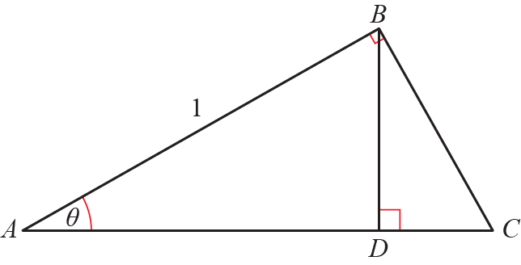

**Figure 1**

Prove that .

**(8 marks)**

___________________________________________________________________________________

**10.** A particle of mass 3 kg is acted on by three forces,, and.

(a) Find the resultant force *R* acting on the particle.

**(2 marks)**

(b) Find the acceleration of the particle, giving your answer in the form

**(2 marks)**

(c) Find the magnitude of the acceleration.

**(2 marks)**

(d) Given that the particle starts at rest, find the exact distance travelled by the particle in the first 10 s.

**(3 marks)**

___________________________________________________________________________________

**11.** Find the values of the constants *A*, *B*, *C*, *D* and *E* in the following identity:



**(5 marks)**

___________________________________________________________________________________

**12.** 

(a) Given that , find the values of the constants *A* and *B*.

**(5 marks)**

(b) Find the exact value of

**(5 marks)**

___________________________________________________________________________________

**13.** Figure 2 shows the curve *C* with parametric equations,, . The curve passes through the *x*-axis at *P*.

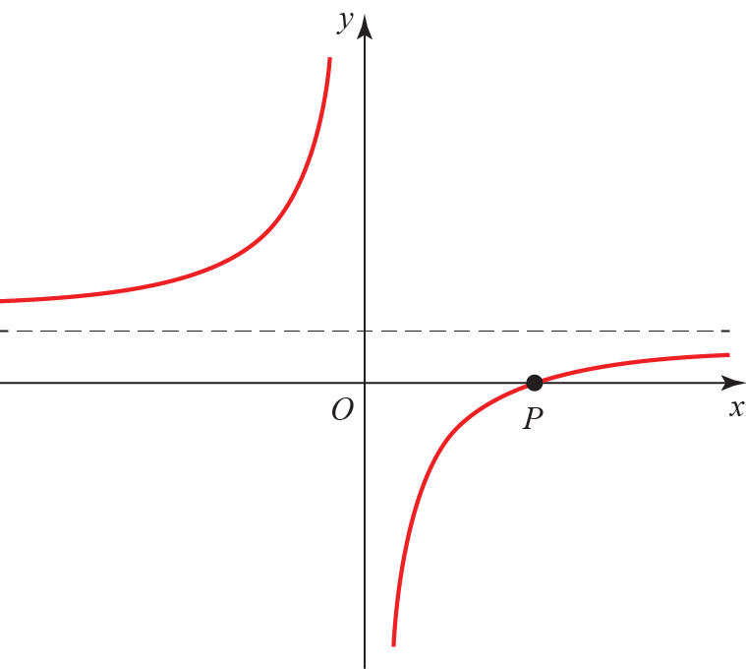

**Figure 2**

(a) Find the coordinate of *P*.

**(2 marks)**

(b) Find the cartesian equation of the curve.

**(2 marks)**

(c) Find the equation of the normal to the curve at the point *t =* −1. Give your answer in the form *ax* + *by* + *c* = 0.

**(6 marks)**

(d) Find the coordinates of the point where the normal meets *C*.

**(4 marks)**

**____________________________________________________________________________**

**TOTAL FOR PAPER IS 100 MARKS**

**BLANK PAGE**