|  |  |
| --- | --- |
| **Pearson Edexcel Level 3** | |
| **GCE Mathematics**  **Advanced Level**  **Paper 1 or 2: Pure Mathematics** | |
| **Practice Paper B**  **Time: 2 hours** | **Paper Reference(s)** |
| **9MA0/01 or 9MA0/02** |
| **You must have:**  **Mathematical Formulae and Statistical Tables, calculator** | |

**Candidates may use any calculator permitted by Pearson regulations. Calculators must not have the facility for algebraic manipulation, differentiation and integration, or have retrievable mathematical formulae stored in them.**

**Instructions**

• Use black ink or ball-point pen.

• If pencil is used for diagrams/sketches/graphs it must be dark (HB or B).

• Answer **all** questions and ensure that your answers to parts of questions are clearly labelled.

• Answer the questions in the spaces provided – *there may be more space than you need*.

• You should show sufficient working to make your methods clear. Answers without working may not gain full credit.

• Inexact answers should be given to three significant figures unless otherwise stated.

**Information**

• A booklet ‘Mathematical Formulae and Statistical Tables’ is provided.

• There are 13 questions in this paper. The total mark is 100.

• The marks for each question are shown in brackets – *use this as a guide as to how much time to spend on each question.*

**Advice**

• Read each question carefully before you start to answer it.

• Try to answer every question.

• Check your answers if you have time at the end.

• If you change your mind about an answer, cross it out and put your new answer and any working underneath.

**Answer ALL questions.**

**1.** Use proof by contradiction to prove the statement: ‘The product of two odd numbers is odd.’

**(5 marks)**

**___________________________________________________________________________________**

**2.** (a) Prove that the sum of the first *n* terms of an arithmetic series is .

**(3 marks)**

(b) Hence, or otherwise, find the sum of the first 200 odd numbers.

**(2 marks)**

**___________________________________________________________________________________**

**3.** A curve has the equation.

Show that the equation of the tangent at the point with an *x*-coordinate of 1 is

.

**(6 marks)**

**___________________________________________________________________________________**

**4.** The curve *C* has parametric equations,,.

(a) Show that the cartesian equation of *C* can be written as, where *a*, *b* and *c* are integers which should be stated.

**(3 marks)**

(b) Sketch the curve *C* on the given domain, clearly stating the endpoints of the curve.

**(3 marks)**

(c) Find the length of *C*. Leave your answer in terms of *π*.

**(2 marks)**

**___________________________________________________________________________________**

**5.** The coordinates of *A* and *B* are (−1, 7, *k*) and (4, 1, 10) respectively. Given that the distance from *A* to *B* is units,

(a) find the possible values of the constant *k*.

**(3 marks)**

(b) For the larger value of *k*, findthe unit vector in the direction of .

**(3 marks)**

**___________________________________________________________________________________**

**6.** Given that, find the value of *b* showing each step in your working.

**(8 marks)**

**___________________________________________________________________________________**

**7.** A sequence is given by, where *p* is an integer.

(a) Show that.

**(2 marks)**

Given that,

(b) find the value of *p*.

**(3 marks)**

(c) Hence find the value of.

**(1 mark)**

**___________________________________________________________________________________**

**8.** Express  as a single fraction in its simplest form.

**(4 marks)**

**___________________________________________________________________________________**

**9.** The diagram shows the graph of h(*x*).

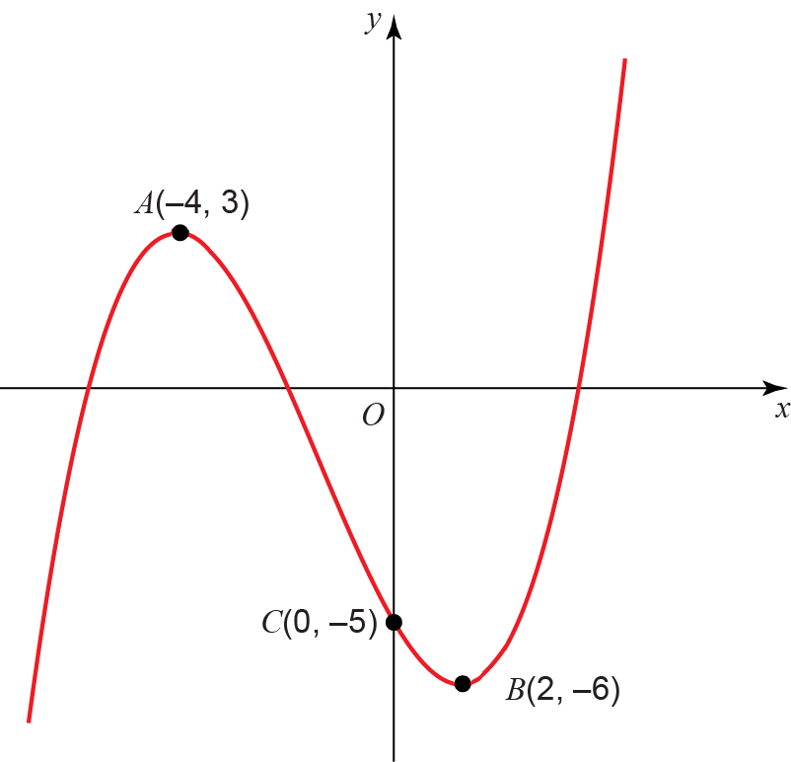

**Figure 1**

The points *A*(−4, 3) and *B*(2, −6) are turning points on the graph and *C*(0, −5) is the *y*-intercept. Sketch on separate diagrams, the graphs of

(a) *y* = |f(*x*)|

**(3 marks)**

(b) *y* = f(|*x*|)

**(3 marks)**

(c) *y* = 2f(*x* + 3)

**(3 marks)**

Where possible, label clearly the transformations of the points *A*, *B* and *C* on your new diagrams and give their coordinates.

**___________________________________________________________________________________**

**10. **

(a) By drawing an appropriate sketch, show that there is only one solution to the equation g(*x*) = 0.

**(2 marks)**

(b) Show that the equation g(*x*) = 0 may be written in the form *x* = 2e−*x* + 1.

**(2 marks)**

Let *x*0 = 1.5.

(c) Use the iterative formula to find to 4 decimal places the values of *x*1, *x*2, *x*3 and *x*4.

**(2 marks)**

(d) Using *x*0 = 1.5 as a first approximation, apply the Newton–Raphson procedure once to g(*x*) to find a second approximation to *α*, giving your answer to 4 decimal places.

**(4 marks)**

**___________________________________________________________________________________**

**11.** (a) Find the binomial expansion of  in ascending powers of *x* up to and including the *x*2 term, simplifying each term.

**(4 marks)**

(b) State the set of values of *x* for which the expansion is valid.

**(1 mark)**

(c) Show that when , the exact value of  is .

**(2 marks)**

(d) Substitute  into the binomial expansion in part (a) and hence obtain an approximation to. Give your answer to 5 decimal places.

**(3 marks)**

**___________________________________________________________________________________**

**12.** The diagram shows the curve with equation

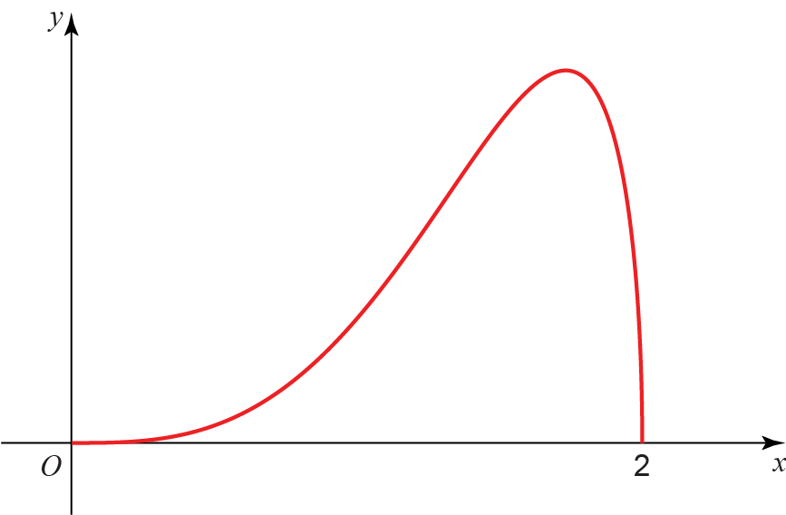

**Figure 2**

(a) Complete the table with the value of *y* corresponding to *x* = 1.5. Give your answer correct to 5 decimal places.

|  |  |  |  |  |  |
| --- | --- | --- | --- | --- | --- |
| ***x*** | 0 | 0.5 | 1 | 1.5 | 2 |
| ***y*** | 0 | 0.12103 | 0.86603 |  | 0 |

**(1 mark)**

Given that,

(b) use the trapezium rule with 4 equal width strips to find an approximate value of *I*,   
giving your answer to 4 significant figures.

**(3 marks)**

(c) By using an appropriate substitution, or otherwise, find the exact value of, leaving your answer as a rational number in its simplest form.

**(6 marks)**

(d) Suggest one way in which your estimate using a trapezium rule could be improved.

**(1 mark)**

**___________________________________________________________________________________**

**13.** (a) Express 5 cos *θ* – 8 sin *θ* in the form *R* cos (*θ* + *α*), where *R* > 0 and 0 < *α* < π. Write *R* in surd form and give the value of *α* correct to 4 decimal places.

**(4 marks)**

The temperature of a kiln, *T*°C, used to make pottery can be modelled by the equation , where *x* is the time in hours since the pottery was placed in the kiln.

(b) Calculate the maximum value of *T* predicted by this model and the value of *x*, to 2 decimal places, when this maximum first occurs.

**(4 marks)**

(c) Calculate the times during the first 24 hours when the temperature is predicted, by this model, to be exactly 1097  °C.

**(4 marks)**

**___________________________________________________________________________________**

**TOTAL FOR PAPER IS 100 MARKS**

**BLANK PAGE**